**Medical Diagnosis : Heart Diseases**

**Abstract:**

This project aims to develop a predictive model for detecting heart disease based on various risk factors and medical attributes. By leveraging machine learning techniques and predictive modelling, the goal is to create a tool that can assist in early detection and diagnosis of heart-related conditions.

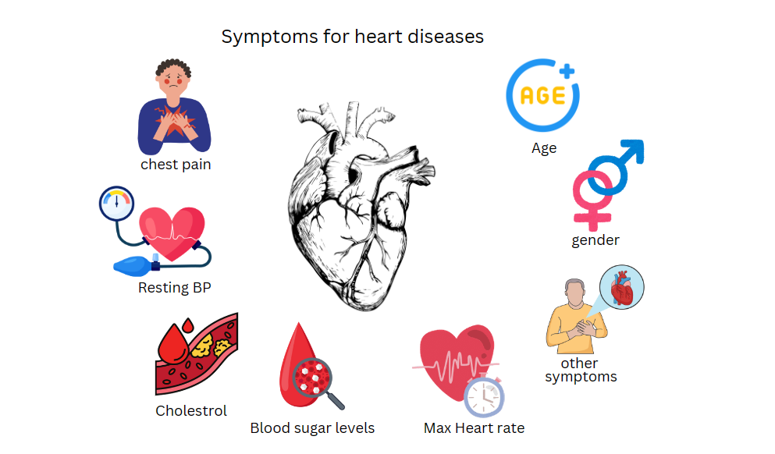

**Project Description:**

* **Data Collection**: Gather a comprehensive dataset containing information such as age, sex, cholesterol levels, blood pressure, and other relevant features associated with heart disease.
* **Data Preprocessing**: Clean and preprocess the data to handle missing values, normalize features, and ensure data quality for model training.
* **Model Development**: Build and train a machine learning model using algorithms like Support Vector Machines (SVM), Random Forest, or Logistic Regression to predict the likelihood of heart disease based on the input features.
* **Model Evaluation**: Evaluate the model's performance using metrics like accuracy, precision, recall, and F1 score to assess its effectiveness in predicting heart disease cases.
* **Interactive Prediction Tool**: Develop an interactive tool that allows users to input their medical data and receive real-time predictions on their risk of heart disease.

**Technologies and Platforms used :  
 Platform:** Jupyter Notebook

**Libraries required:**

1. Pandas
2. Seaborn
3. Matplotlib
4. Scikit-learn

**Dataset:**

Heart Disease Dataset link : click [here](https://www.kaggle.com/datasets/mexwell/heart-disease-dataset?select=heart_statlog_cleveland_hungary_final.csv)

**Code file:**

Medical diagnosis Heart diseases.ipynb